Preliminary

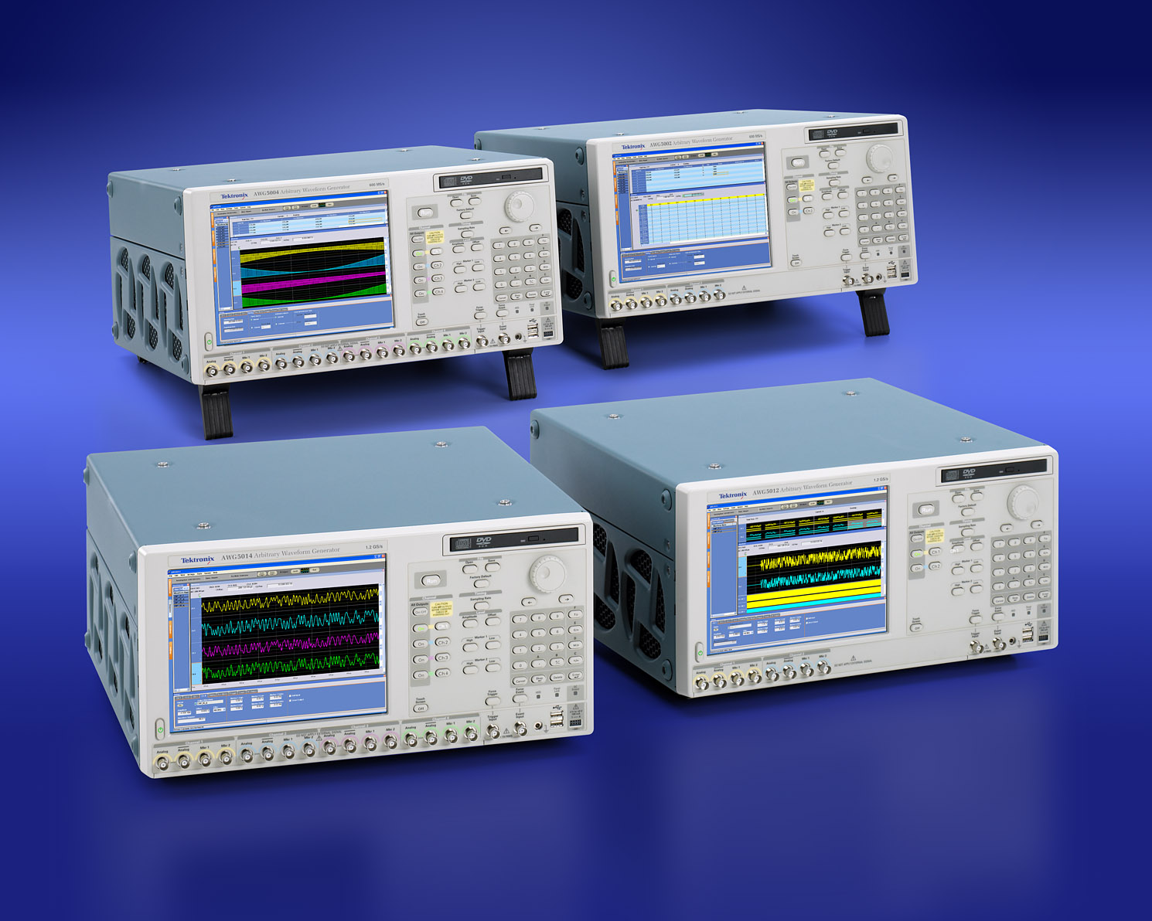

The AWG5000 series Arbitrary Waveform Generator
Delivers the industry’s best mixed signal stimulus solution for Ever- Complicating Measurement Challenges

The AWG5000 series Arbitrary Waveform Generator Delivers Industry leading combination of sample rate, vertical resolution, signal fidelity and waveform memory length in an easy to use self contained package providing better signal dynamic range and integrity for design engineers.
This family offers the industry’s best solution to the challenging signal stimulus issues faced by designers verifying, characterizing and debugging sophisticated electronic designs.

AWG5000 series models, 14 bits DA converter based sample rate from 600MS/s to 1.2GS/s with 2 to 4ch output , synchronized 4 to 8 digital marker outputs and 28-channels digital data outputs, easily solve the toughest measurement challenges in Wireless base-bans I/Q communications, digital consumer such as imaging, data conversion devices and semiconductor design/test industries.
The open windows (windows XP) based instrument supports easy of use and connect with peripherals and 3rd party software.

Features And Benefits
1.2Gs/s and 600MS/s models
14 bit vertical resolution
2 or 4 arbitrary waveform differential / single-ended outputs
Up to 4.5Vpp at single end and 9Vpp at differential output into 50 ohm
0.9 ns Tr/Tf (10 - 90%) at 1Vpp
+/– 5ns Range (50 ps Resolution) Inter Channel Skew Control
SFDR: 80dBc (1MHz), 64dBc (10MHz)
4 or 8 variable level marker outputs
Up to 3.7Vpp at single-end output into 50 ohm
300 ps Tr/Tf (20 - 80%) at 0 to 1V
Up to 1 ns Range (50ps Resolution) Delay Control
28 bits ch1/ch2 variable level digital data output
Up to 3.7Vpp at single-end output into 50 ohm
300 ps Tr/Tf (20 - 80%) at 0 to 1V
Up to 32M (32,400,000) Point Record Length Provide Longer Data Streams
Down to 100 fs resolution Edge Timing shift control
Sequencing Creates Infinite Waveform Loops, Jumps, and Conditional Branches
Intuitive User Interface Shortens Test Time
Integrated PC Supports Network Integration and Provides a Built-in DVD, Removable Hard Drive, LAN and USB Ports

Applications

Designing, Testing and Deploying:
Wireless communication:
High fidelity Quadrature modulation I&Q Base-band and IF Signals
(two pair of I/Q and four pairs of IF for MIMO, polar modulation: I/Q + magnitude control,)
Imaging
Stimulus Signals for Imaging Display and Recording Devices (CCD, LCD)
Data conversion
Stimulus Signals for data conversion devices (ADC, DAC)
Mixed Signal Design and Test
2/4ch analog + 4/8ch Marker outputs + 28bit digital data outputs
Real-world, Ideal or Distorted Signal Generation – Including All the Glitches, Anomalies and Impairments
Enhanced/Corrupted Playback of DSO Captured Signals
Waveform Vectors Imported from Third-party Tools such as MathCAD, MATLAB, Excel and Others

Wireless I/Q and IF Signal Generation
Now, we can identify “Wireless Everywhere” by Enabled latest Digital RF technology, and continuing increasing wireless network capacity and their performance such as higher modulation bandwidth, modulation schemes.
The 1.2GS/s, (600MS/s) with enough signal dynamic range and SFDR by14bit vertical resolution meets from Narrowband IQ applications to broadband IF applications. AWG5000s is able to generate not only analog IQ/IF but digital data IQ / IF. The MIMO (Multiple Input Multiple Output) system that supports W-LAN /Wi-Max using space-multiplex with multiple antennas is a one of the hottest technologies to be reliable and faster data rate communication. AWG5000 series that generate up to 4 analog channels (8-channels by two boxes) enables to simultaneously generate MIMO signals. AWG5000s can generate two pairs of IQ signals (4-pairs by two boxes) as an IQ generator, and four pairs of IF signals (8-pairs by two boxes) as an IF generator. Also for two channels model, it’s available ch1 and ch2 digital data output as an option.

Figure1: EVM/Constellation measurement
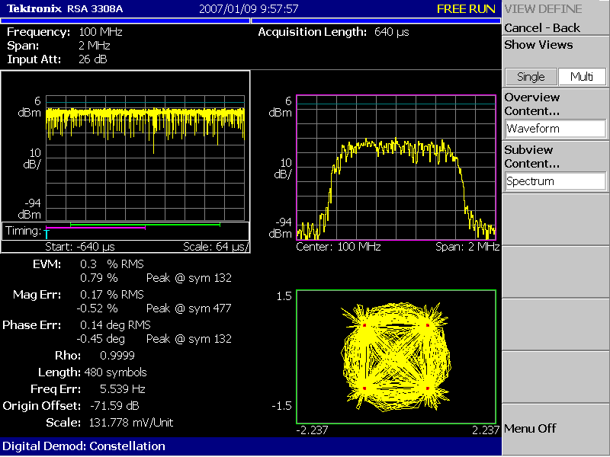

Figure2: Typical Signal Injection
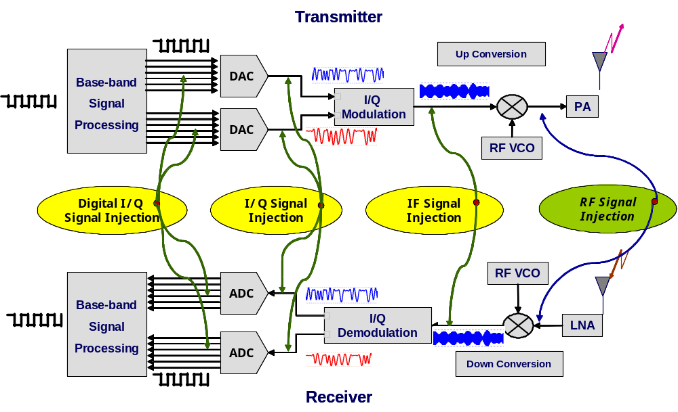
Spurious performance
The 14bit vertical resolution and sophisticated design provides enough signal dynamic range and purity.
The SFDR performance is:
80dBc for 1MHz signal and 64dBc for 10MHz signal.
Figure3: RTSA Spectrum view
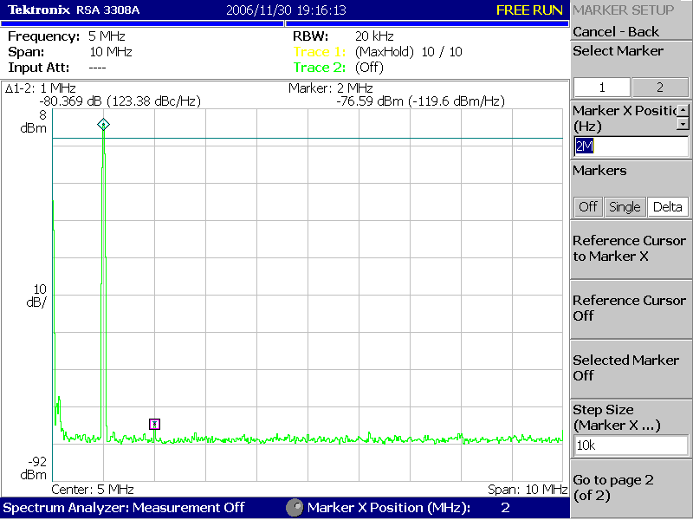

Multi-Level Logic signal
One technique to increase the data rate without increasing the transition rate is by applying multi-level signals, wherein a signal can assume more than the standard binary 2 levels. In multi-level signaling one can think of multi-level discrete amplitudes of a signal. This phenomenon is known as pulse amplitude-modulation or PAM. A 9PAM signal, a signal with 9 different amplitudes, increases the data rate by four without increasing the transition rate of the signal.
The AWG5000 Series enables you to test your latest design by generating any kind of mixed or multi-level signal.

Figure4: 9-PAM with 250Mbps
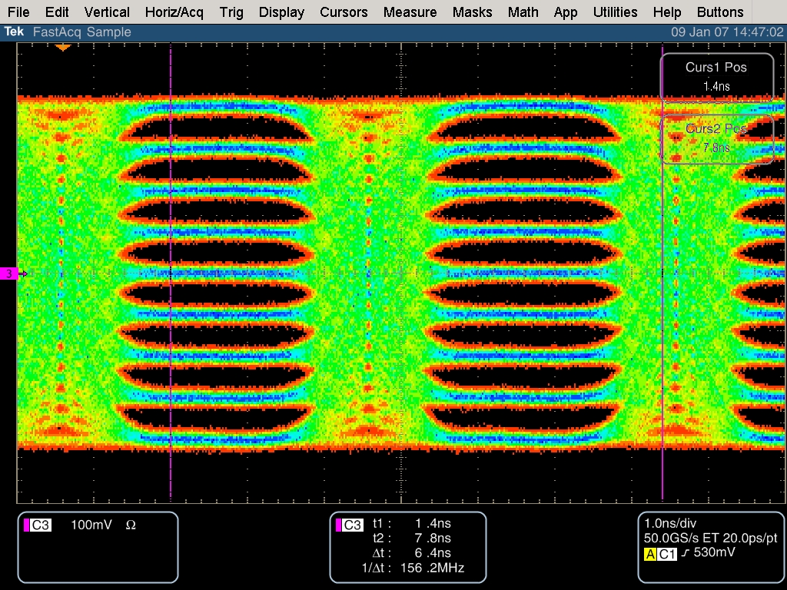

Mixes signal Generation
AWG5012/AWG5002 that generates two analog signals with four digital marker outputs supports 28 digital outputs (ch1 and ch2 data) as an option. They represent mixed signal generator and the most versatile solution for a broad range of applications including consumer electronics such as ADC/DAC converter and imaging or display devices.

Figure5: Mixed signal test by TDS/TLA iView
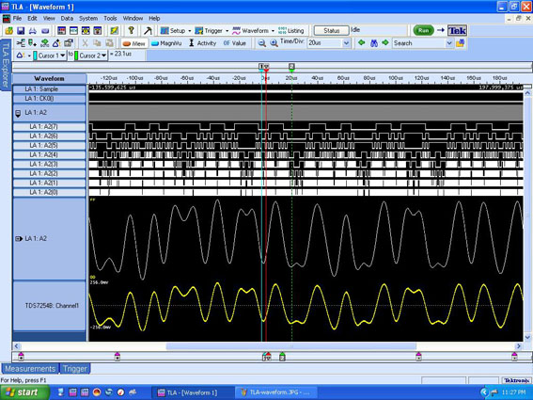

Characteristics
 |  | AWG5014 | AWG5012 |  | AWG5004 | AWG5002
Arbitrary Waveforms
Waveform Length |  | 1 to 16,200,000 points (or 2 to 32,400,000 points, option 01)
Number of Waveforms |  | 1 to 16,000
Sequence Length |  | 1 to 4,000 steps
Sequence Repeat Counter |  | 1 to 65,536 or infinite.
Sequence Control |  | Repeat count, Trigger, Goto-N and Jump
Jump Mode |  | Synchronous and Asynchronous
Run Modes
Continuous |  | Waveform is iteratively output. If a sequence is defined, the sequence order and repeat functions are applied
Triggered |  | Waveform is output only once when an external, internal, GPIB, LAN or manual trigger is received
Gated |  | Waveform begins output when gate is true and resets to beginning when false
Sequence |  | Waveform is output as defined by the sequence
Clock Generator
Sampling Frequency |  | 10MS/s to 1.2 GS/s |  | 10MS/s to 600 MS/s
Resolution |  | 8 digits
Internal Clock
 | Accuracy | With in ± (1 ppm + Aging), Aging: with in ± 1 ppm / year
 | Clock Phase Noise | Less than -90dBc/Hz at 100kHz offset
Internal Trigger Generator
Internal Trigger Rate
 | Range | 1.0 µs to 10.0 s
 | Resolution | 3 digits, 0.1 µs minimum
Skew Control Between Outputs
 | Range | - 5ns to + 5ns
 | Resolution | 5ps

 |  | AWG5014 | AWG5012 | AWG5004 |  |  | AWG5002
Main Arbitrary Waveform Output
Digital to Analog Converter
Resolution |  | 14 bits
Analog Output (in to 50 ohm) (Twice for Hi_Z input)
Number of Arb Outputs |  | 4 | 2 | 4 |  | 2
Output Style |  | Differential
Output Impedance |  | 50 Ω
Skew between (+) and (-) output |  | Less than 200ps
Connector |  | BNC Front
Amplitude
 | Output Voltage | High range; -4.5 V to + 4.5 V, Low range: -3.25V to +3.25V, Direct -0.3V to +0.3V
 | Amplitude | High range; 20mVpk-pk to 4.5Vpk-pk, Low range; 20mVpk-pk to 2.0Vpk-pk,  Direct; 20mVpk-pk to 0.6Vpk-pk
 | Resolution | 1mV
 | DC Accuracy | ±(2.0% of Amplitude + 2 mV) at offset = 0 V
Offset (into 50 ohm)
 | Range | High range/Low range; -2.25V to +2.25V, Direct; N/A
 | Resolution | 1mV
 | Accuracy | ±(2% of offset +10 mV at minimum amplitude
Pulse response
Rise/Fall time: (10 to 90%). |  | Normal: ≤ 1.5ns (4.5Vpp), ≤1.4ns (2.0Vpp), Direct; ≤0.95ns (0.6Vpp)
Bandwidth (-3dB) |  | Normal: 230MHz (4.5Vpp), 250MHz (2.0Vpp), Direct; 370MHz (0.6Vpp)
Ringing |  | Normal: 750mVpp (4.5Vpp), 80mVpp (2.0Vpp), Direct; 60mVpp (0.6Vpp)
Low Pass Filter |  | Normal: 20MHz, 100MHz, Through, Direct; N/A
Delay from Marker |  | Normal: 17.5ns to 19.4ns (20MHz filter), 3.8ns to 5.7ns (100MHz filter), 0 to 1.9ns (Through),  Direct: -1.5ns to 0.4ns
Sine Wave Characteristics |  | (1.2GS/s clock, 32 waveform points, 37.5MHz signal frequency) |  |  | (600MS/s clock, 32 waveform points, 18.75 MHz signal frequency)
Harmonics |  | Normal: ≤-40 dBc (2.0Vpp), Direct ≤-49 dBc (0.6Vpp) |  |  | Normal: ≤-46 dBc (2.0Vpp), Direct ≤-55 dBc (0.6Vpp)
Non Harmonics |  | Normal: ≤-60 dBc (2.0Vpp, DC to 600MHz) |  |  | Normal: ≤-60 dBc (2.0Vpp, DC to 300MHz)
Phase noise |  | ≤-85 dBc/Hz (2.0Vpp, 10 kHz offset) |  |  | ≤-85 dBc/Hz (2.0Vpp, 10 kHz offset)
SFDR (spurious free dynamic range)
 |  | 50dBc (Normal, 37.5MHz, 1.2GS/s, 2.0Vpp)  60dBc (Normal, 10MHz, 600MS/s, 1.0Vpp)  80dBc (Normal, 1MHz, 600MS/s, 1.0Vpp)  64dBc (Direct, 10MHz, 600MS/s, 0.6Vpp)  80dBc (Direct, 1MHz, 600MS/s, 0.6Vpp) |  |  | 56dBc (Normal, 18.75MHz, 600MS/s, 2.0Vpp)  60dBc (Normal, 10MHz, 600MS/s, 1.0Vpp)  80dBc (Normal, 1MHz, 600MS/s, 1.0Vpp)  64dBc (Direct, 10MHz, 600MS/s, 0.6Vpp)  80dBc (Direct, 1MHz, 600MS/s, 0.6Vpp)

 |  | AWG5014 | AWG5012 |  | AWG5004 |  | AWG5002
Auxiliary Outputs
Marker output
Number of Outputs |  | 4 (2 per ch) | 2 |  | 4 (2 per ch) |  | 2
Output Style |  | Single Ended
Output Impedance |  | 50 Ω
Connector |  | BNC Front
Level (into 50 ohm) (Twice for Hi_Z input)
 | Output Windows | -1.00 V to + 2.7 V
 | Amplitude | 0.10Vpk-pk to 3.7 Vpk-pk
 | Resolution | 10mV
DC Accuracy |  | ± (10% of setting +120mV)
Maximum Output current |  | ± 54mA /ch
Rise/Fall Time (20% to 80%) |  | <300 ps (1.0 Vp-p, Hi +1.0 V, Lo 0 V)
skew adjust between markers
 | range | 0 to 1000ps
 | resolution | 50ps
Random Jitter (Typical) |  | 1010 clock pattern
 | rms | 5ps rms
Total Jitter (Typical) |  | 2^15-1 PN data pattern
 | peak to peak | 150ps peak to peak
Clock (VCO) out
Range |  | 600MHz to 1.2GHz
Amplitude |  | 0.4Vp-p into 50Ω to GND
Impedance: |  | 50Ω, AC coupling
Connector |  | BNC Rear
10MHz Reference Out
Amplitude |  | 1.2 Vp-p into 50 Ω. Max 2.5 Vp-p open.
Impedance |  | 50 Ω, AC coupling
Connector |  | BNC Rear
DC Outputs
Number of Outputs |  | 4 : independently controlled outputs
Range |  | -3.0 to +5.0 V
Resolution |  | 10mV
Max. current |  | ± 100 mA
Connector |  | 2x4 pin header on front panel
Digital Data Output (Option 03)
Number of Output |  | NA |  | 14 bits output on channel1 and channel2 (28 total) |  | NA |  | 14 bits output on channel1 and channel2 (28 total)
Output Style |  |  |  | Single-ended |  |  |  | Single-ended
Output Impedance |  |  |  | 50 ohm |  |  |  | 50 ohm
Connector |  |  |  | SMB rear |  |  |  | SMB rear
Level (into 50 ohm) (Twice for Hi_Z input)
Output Windows |  |  |  | -1.00 V to + 2.7 V |  |  |  | -1.00 V to + 2.7 V
Amplitude |  |  |  | 0.10Vpk-pk to 3.7 Vpk-pk |  |  |  | 0.10Vpk-pk to 3.7 Vpk-pk
Resolution |  |  |  | 10mV |  |  |  | 10mV
DC Accuracy |  |  |  | ± (10% of setting +120mV) |  |  |  | ± (10% of setting +120mV)
Maximum Output current |  |  |  | ± 54mA /ch |  |  |  | ± 54mA /ch
Rise/Fall Time (20% to 80%) |  |  |  | <300 ps (1.0 Vp-p, Hi +1.0 V, Lo 0 V) |  |  |  | <300 ps (1.0 Vp-p, Hi +1.0 V, Lo 0 V)
Delay from Marker |  |  |  | - 41ns to - 82ns |  |  |  | - 41ns to - 82ns
Skew between Digital outputs |  |  |  | Less than 400ps |  |  |  | Less than 400ps

Auxiliary Inputs
Trigger In
 | Impedance: | 1 kΩ or 50 Ω.
 | Polarity | POS or NEG.
 | Connector | BNC Front
Input Voltage Range |  | 1 kΩ: ±10 V. 50 Ω: ±5 V.
Threshold -
 | Level | -5.0 V to 5.0 V.
 | Resolution | 0.1V
Trigger Jitter |  | 2.0ns to 4.5ns (Typical)
Trigger Mode -
 | Minimum Pulse Width: | 20 ns
 | Trigger Hold-off | 160 * sampling_period - 200ns
 | Delay to Analog Out | 48 * sampling_period + 500ns
Gate Mode
 | Minimum Pulse Width: | 1024 * sampling_period + 10ns
 | Delay to Analog Out | 240 * sampling_period + 500ns
Event Input
Impedance: |  | 1 kΩ or 50 Ω.
Polarity |  | POS or NEG.
Connector |  | BNC Front
Input Voltage Range |  | 1 kΩ: ±10 V. 50 Ω: ±5 V.
Threshold - |  | -5.0 V to 5.0 V.
Resolution |  | 0.1V
Sequence mode Mode
 | Minimum Pulse Width: | 20 ns
 | Event Hold Off | 260 * Sampling Period + 300 ns
 | Delay to Analog Out | 200 * Sampling Period + 500ns (Jump timing: Asynchronous jump)
External Clock IN
Input Voltage Range: |  | 0.2 Vp-p to 0.8 Vp-p,
Impedance: . |  | 50 Ω, AC coupled
Frequency Range: |  | 600MHz to 1.2GHz:
Clock Divider |  | 1/1, 1/2, 1/4……1/32 |  | 1/2, 1/4……1/32
Connector: |  | BNC Rear
Reference Clock IN
Input Voltage Range: |  | 0.2 Vp-p to 3.0 Vp-p
Impedance: |  | 50 Ω, AC coupled.
Frequency Range: |  | 10 MHz, 20 MHz, 100 MHz (with ±0.5%)
Connector: |  | BNC Rear
Phase Lock IN
Input Ranges |  | 5 MHz to 800 MHz (acceptable frequency drift is ±0.5%)
Input Voltage Range: |  | 0.2 Vp-p to 3 Vp-p
Impedance: |  | 50 Ω, AC coupled.
Multiple Rate |  | 1 to 240 | 1 to 120
Connector: |  | BNC Rear

 | AWG5000 series common features
Waveform file Import capability | Tektronix TDS5000/6000, TDS/CSA7000, TDS/CSA/DSA8000, DPO7000, DPO/DSA70000 (*.wfm). TDS3000, DPO4000 (*.ISF)  AWG400s/500s/610/615/710/710B (*.wfm, *.pat, *.seq), AFG3000 (*.TFW), DTG5000s (*.DTG)  Text data file (3rd party software creation waveform data: MATLAB, MathCad, Excel)
S/W driver for 3rd party S/W | IVI-COM driver and MATLAB library
Instrument Control/Data Transfer Ports
GPIB | Remote control and data transfer. (Conforms to IEEE-Std 488.1, compatible with IEEE 488.2 and SCPI-1999.0).
Ethernet (10/100/1000Base-T) | Remote control and data transfer. (Conforms to IEEE 802.3). RJ-45
Computer System & Peripherals | Windows XP Professional, 512 MB SDRAM, 80 GB removable Hard Drive at rear (available front mount kit), CD-RW/DVD drive at front, included USB compact keyboard and mouse
PC I/O Ports | USB 2.0 compliant ports (6 total, 2 front, 4 rear), PS/2 mouse and keyboard connectors (rear panel), RJ-45 Ethernet connector (rear panel) supports 10/100/1000 BASE-T, XGA out
Display Characteristics | 10.4 inch, LCD color display with touch screen, 1024 (H) × 768 (V) (XGA).
Mechanical Cooling | -
Required Clearance
Top and Bottom | 2 cm (0.8 inch)
Side | 15 cm (6 inch)
Rear | 7.5 cm (3 inch)
Power Supply | 100 to 240 VAC, 47 to 63 Hz.
Power Consumption | 560 W.
Safety - | UL61010-1, CAN/CSA-22.2, No.61010-1-04, EN61010-1, IEC61010-1
Emissions | EN 55011 (Class A), IEC61000-3-2, IEC61000-3-3
Immunity | IEC61326, IEC61000-4-2/3/4/5/6/8/11

Regional Certifications
Europe: | EN61326
Australia/New Zealand: | AS/NZS 2064.
Physical Characteristics
Dimension | mm | in.
Height | 245 | 9.6
Width | 465 | 18.0
Length | 500 | 19.7
Weight (approx.) | kg | lbs.
Net | 19.5 | 43.0
Net with Package | 28.5 | 62.8

Environmental
 | Operation | Non-operation
Temperature | +10° C to +40° C | -20° C to +60° C
Humidity | 5% to 80% relative humidity (% RH) at up to +30° C,  5% to 45% RH above +30° C up to +50° C, | 5% to 90% RH (Relative Humidity) at up to +30° C,  5% to 45% RH above +30° C up to +50° C,
Altitude | Up to 3,048 meters (10,000 feet) | Up to 12,192 meters (40,000 feet)
Random Vibration | 0.27 GRMS, 5 to 500 Hz, 10 minutes per axis | 2.28 GRMS, 5 to 500 Hz, 10 minutes per axis
Sine Vibration | 0.33 mm pk-pk (0.013 inch p-p) constant displacement, 5 55 Hz | NA
Mechanical shock | Half-sine mechanical shocks, 30 g peak amplitude, 11 msec duration, 3 drops in each direction of each axis | NA

Ordering Information
Arbitrary Waveform Generator mainframe
AWG5014
1.2GS/s, 4ch, 14bits, 16M point/ch Arbitrary Waveform Generator
AWG5012
1.2GS/s, 2ch, 14bits, 16M point/ch Arbitrary Waveform Generator
AWG5004
600MS/s, 4ch, 14bits, 16M point/ch Arbitrary Waveform Generator
AWG5002
600MS/s, 2ch, 14bits, 16M point/ch Arbitrary Waveform Generator

All models Include: Accessory pouch, front cover, USB mouse, compact USB key board, lead set for DC Output, Stylus for touch screen 2 ea,
Windows® XP operating system restore DVD and instructions, AWG5000 Series product software CD and instructions, Document CD with Browser, Quick Start User Manual, registration card, Certificate of Calibration, power cable.

Please specify power cord and language option when ordering

Instrument Options

Product Options, AWG5014/AWG5012/AWG5004/AWG5002
- Opt. 01 - Waveform Length Expansion (from 16M to 32M)

Product Options, AWG5012/ AWG5002
- Opt. 03 - 28 bits digital data outputs (digital data of ch1 and ch2)

Common options:
International Power Plugs
Opt. A0 - North America power.
Opt. A1 - Universal EURO power.
Opt. A2 - United Kingdom power.
Opt. A3 - Australia power.
Opt. A5 - Switzerland power.
Opt. A6 - Japan power.
Opt. A10 - China power.
Opt. A99 - No power cord or AC adapter.

Language Options
Opt. L0 - English.
Opt. L5 - Japanese.
Opt. L7 - Simplified Chinese.
Opt. L8 - Traditional Chinese.

Service
Following service option and service program are available for AWG7000s (AWG7102, 7101,7052 and 7051)
Option: (e.g. AWG7102 opt. C3)
Opt. CA1 - A single calibration event.
Opt. C3 - Calibration service 3 years.
Opt. C5 - Calibration service 5 years.
Opt. D1 - Calibration data report.
Opt. D3 - Calibration data report 3 years (with option C3).
Opt. D5 - Calibration data report 5 years (with option C5).
Opt. R3 - Repair service 3 years.
Opt. R5 - Repair service 5 years.
Service post-sales offering: (e.g. AWG5012-CA1)
-CA1 - A single calibration event.
-R3DW - Repair service coverage 3 years.
-R5DW - Repair service coverage 5 years.
-R2PW - Repair service coverage 2 years post warranty.
-R1PW - Repair service coverage 1 year post warranty.

Product Upgrade, AWG5014
- AWG50UP
- Opt. M14 Waveform Length Expansion from 16M point to 32 M point
Product Upgrade, AWG5012
- AWG50UP
Opt. M12 Waveform Length Expansion from 16M point to 32 M point
Opt. D13 Digital Data Outputs
Product Upgrade, AWG5004
- AWG50UP
- Opt. M04 Waveform Length Expansion from 16M point to 32 M point
Product Upgrade, AWG5002
- AWG50UP
Opt. M02 Waveform Length Expansion from 16M point to 32 M point
Opt. D03 Digital Data Outputs

Recommended Accessories

Item | Description | Parts Number
Transition Time Converter | 150 ps (10% to 90%) | 015-0710-00
 | 250 ps (10% to 90%) | 015-0711-00
 | 500 ps (10% to 90%) | 015-0712-00
 | 1000 ps (10% to 90%) | 015-0713-00
 | 2000 ps (10% to 90%) | 015-0714-00
Pin Header SMA Cable | 102 cm (40 inch) | 012-1690-00
Pin Header SMB Cable | 51cm (20 inch) | 012-1503-00
Rack Mount kit | Rack Mount Kit with instruction | 016-1983-00
Replacement Hard Disk | SATA disk assembly (no software installation) | 065-0753-00
Quick Start User Manual | English | 071-2078-00
Quick Start User Manual | Japanese | 071-2079-00
Quick Start User Manual | Simplified Chinese | 071-2080-00
Quick Start User Manual | Traditional Chinese | 071-2081-00
Technical Reference | Technical Reference (Spec/PV Manual) | 071-1853-00
Service Manual | Service Manual, English | 071-1854-00

Warranty
One-year parts and labor.

